* CB FSD - Integration and Deployment

Day 11 : 1 Aug 2024

Create EC2 instance and launch it.

Deploy angular/spring boot application on EC2 instance using Docker.

1. Local machine create application ie angular or spring boot.
2. Then create jar file or build file.
3. Then create Dockerfile for build file
4. Then create image using docker build command.
5. Create the tag for that image.
6. Then push this image to docker hub account.
7. We need to create EC2 instance
8. Then open the respective port number in security group.
9. Then install docker and start docker service
10. Then pull the image and run the image on ec2 instance.

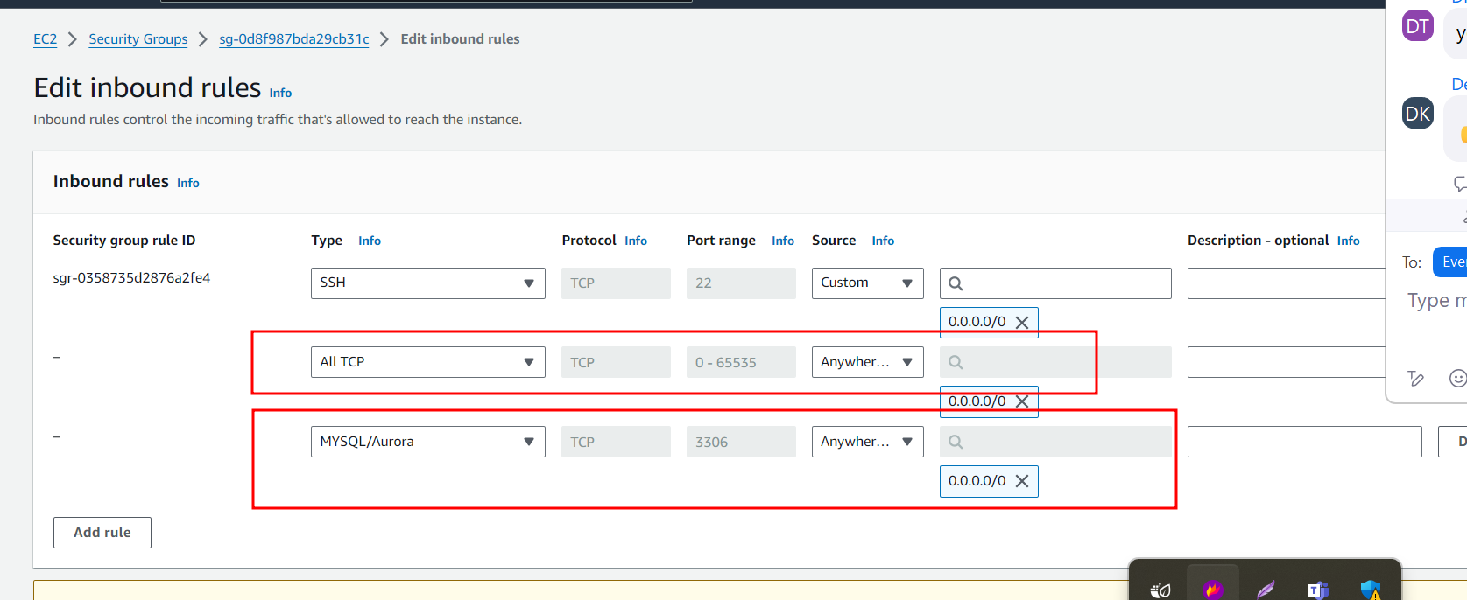

permanently delete